**INVOICE**

Sam Bradshaw

Bell House

Silver Street

Kedington

Haverhill

CB9 7QG

Mob: 07872 597843

Date of Issue: 28/02/2019

Invoice number: 2

Client: Korg UK

Works Carried Out: Further work to website [www.reonsynth.com](http://www.reonsynth.com), including addition of translate widget, tweaks to CSS, and hyperlinks in news items.

**Total Cost: £200**

Account to be credited:

Santander

Account Name: Mr S C Bradshaw

Sort Code: 09 01 29

Account Number: 02944443

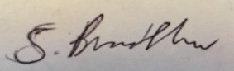

Signed: Date: 28/02/2019